Week 2 assignment

Clearly write your answers in the space provided.
- Solve each equation; show your work for full marks.

- 4(7x + 6) = 5(4x − 1) + 11 | - 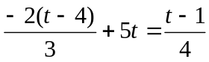
- 0.04x + 0.08(20 − x ) = 1.4 | - 5w + 4 = 3( 2w − 1 ) − w +7
- 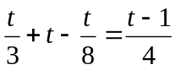 | - 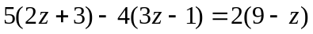

- Solve each literal equation for the indicated variable.
- A = 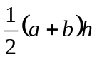 (solve for b ) | - 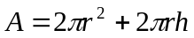 (solve for h)

- Solve the following question. Be sure to define the variable and show the equation you used and clearly state your answer in a sentence.

- Three-eighth’s of Karen’s monthly net income goes to pay her rent. What is her monthly net income if her rent is $750 per month?

- Solve and graph the solution set of the following inequality.

- 3x + 13 < 7x + 19

